Task-1: A Real Time Linear Chart

Position1: Start

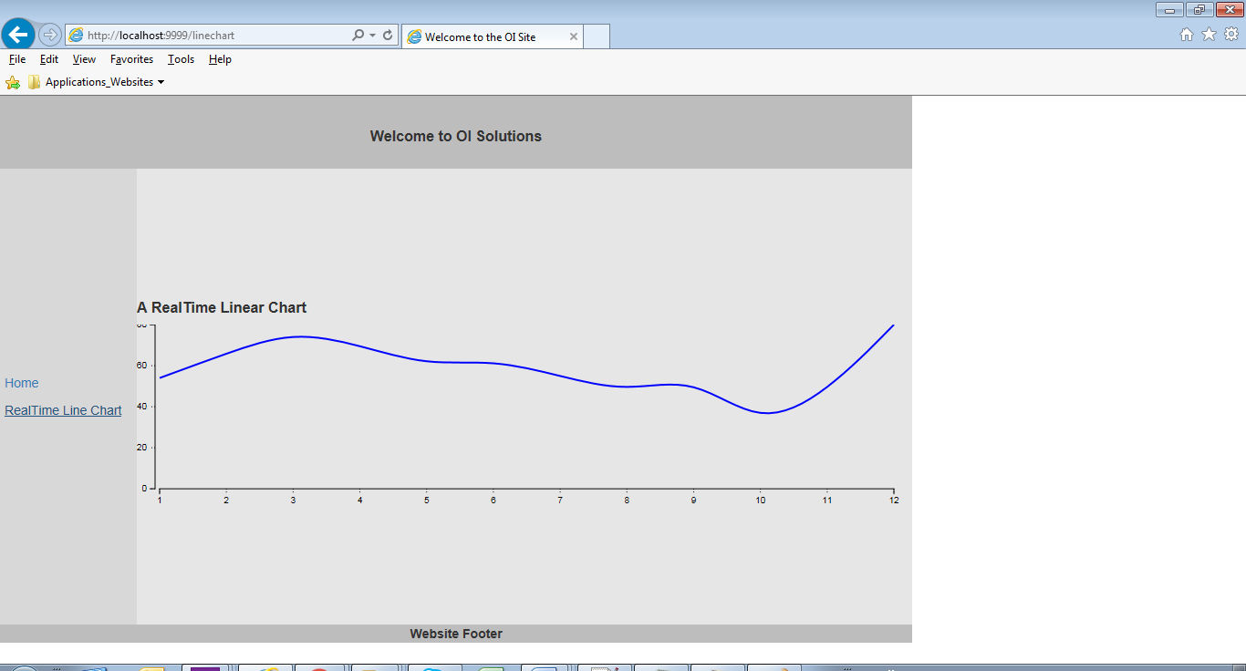

PositionN: In motion

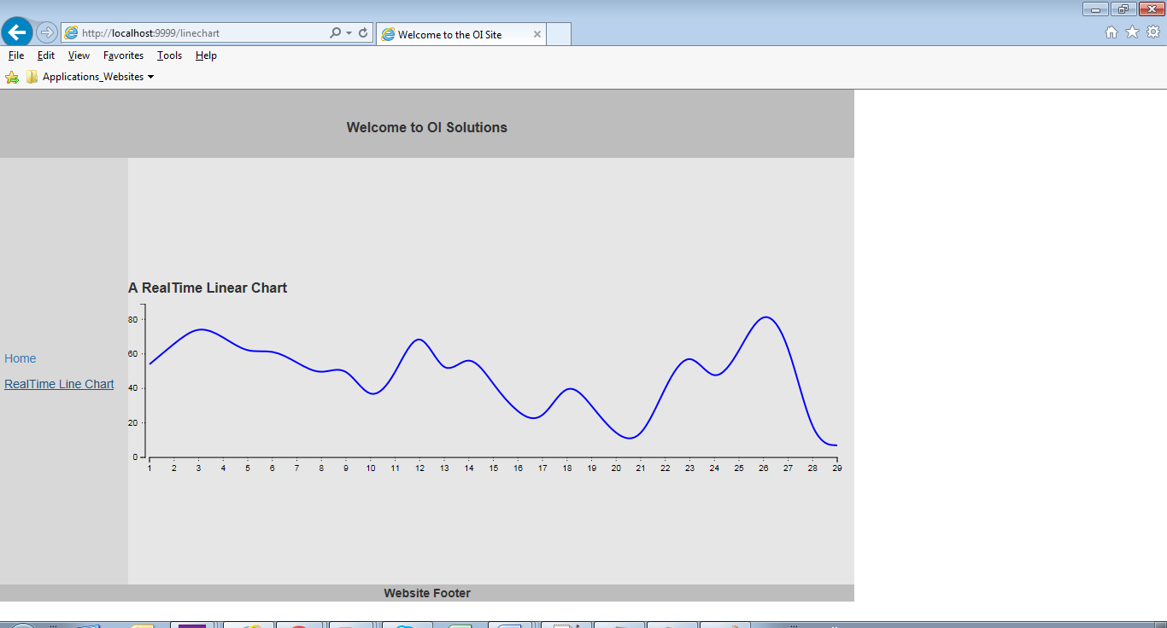

Task-2: A site, asks for a permission to read your current location, and then uses the http://openweathermap.org/current public API to fetch the weather for that location and displays it.

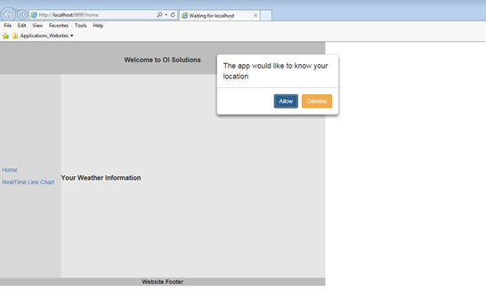

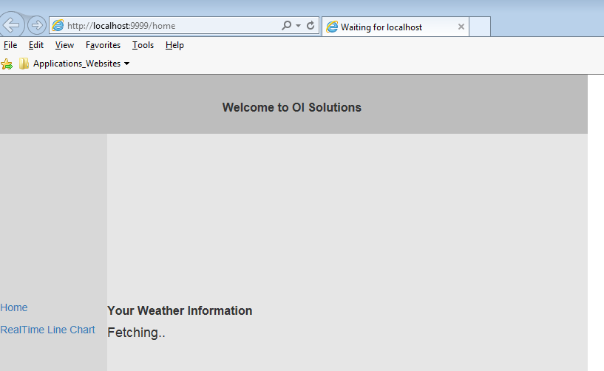

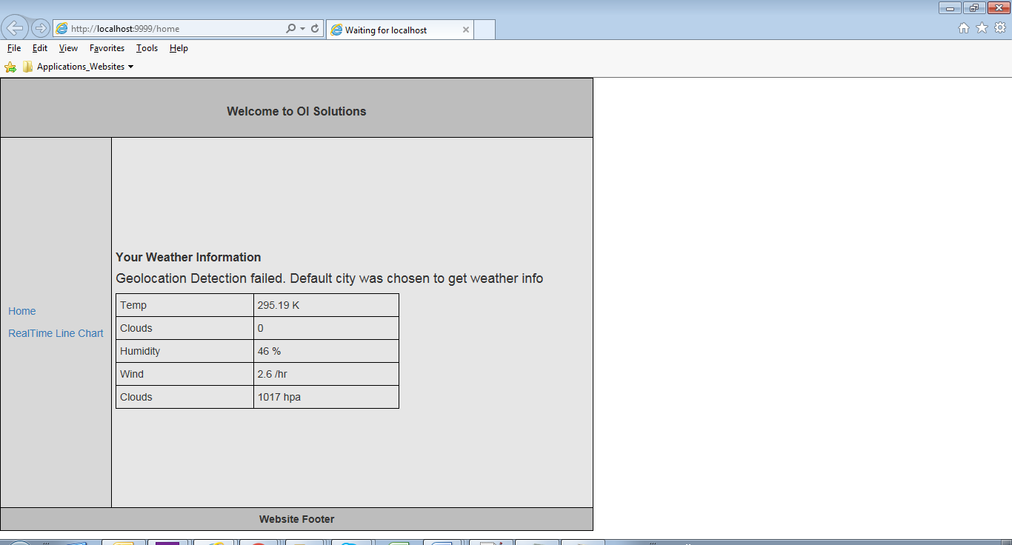

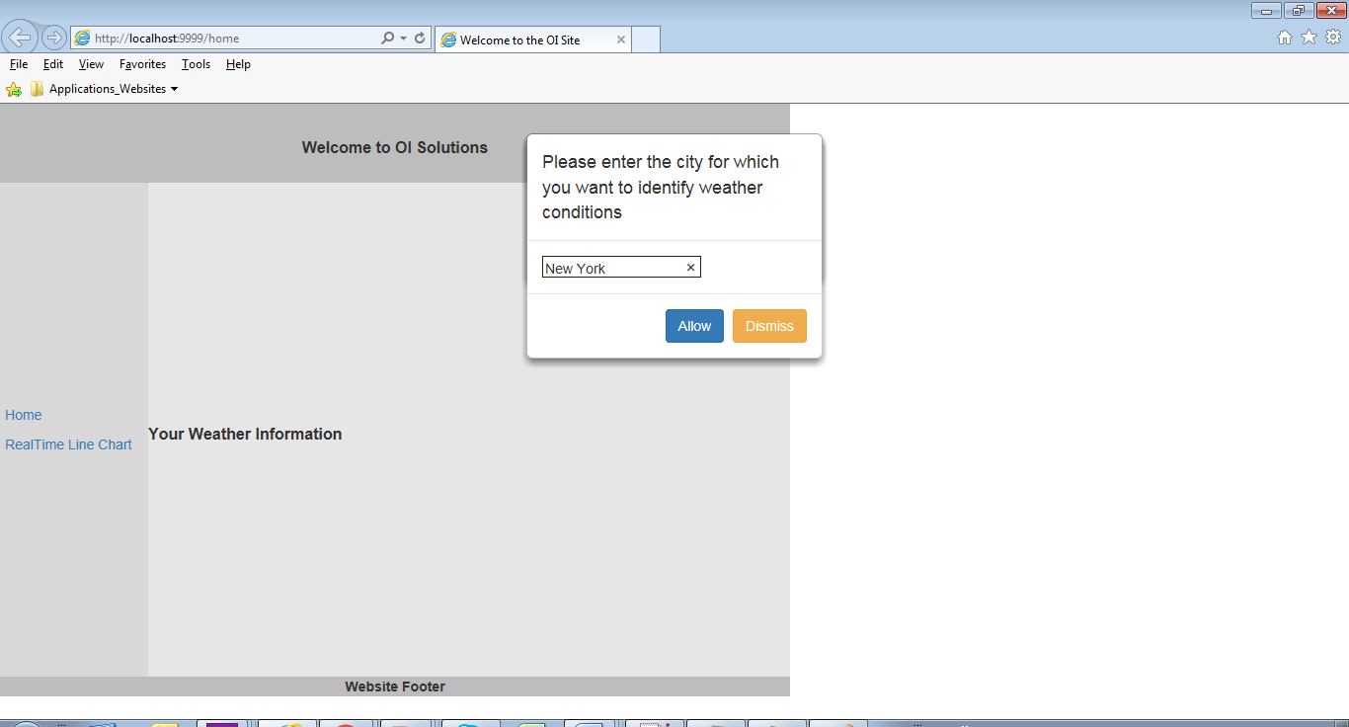

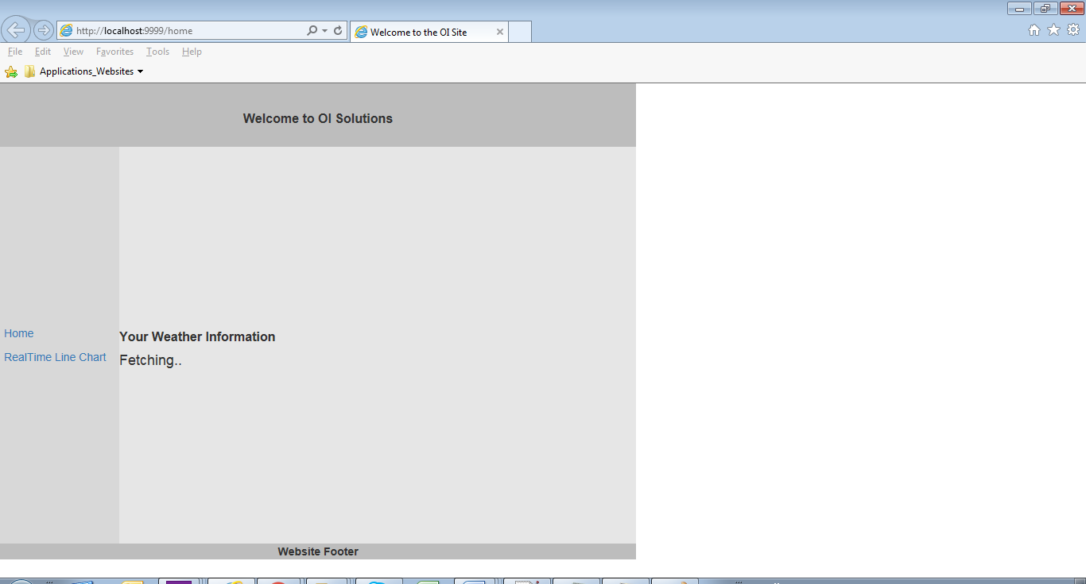



If the api allowed cross origin calls for html then something like below would have been possible without writing code for putting data into a tabular form, as shown below:-

